A critical analysis of this untitled image by the photographer and artist, Paval Titovich.
born 1983 in Belarus, USSR, now Belgorod, Russia.
Introduction
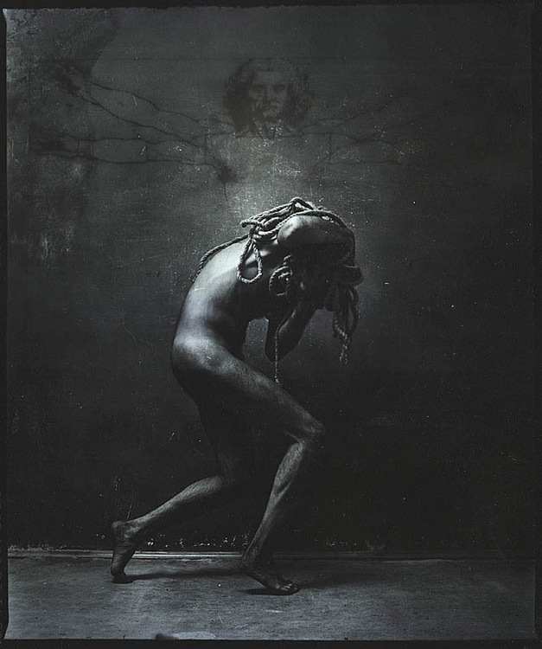
I have chosen an artistic image over that of a ‘factual’ or press image. This allows me the freedom to present my own connotations of what is set out before me.
Paval Titovich seems to be a very private man. There is scarcely any information about him to be had. Even his website is devoid of all but the essential information to guide you round his Spartan site. There is a distinct style to Titovich’ work, which is typified by this image. It is one of a series of twelve, entitled ‘Labyrinth’.
After having analysed this image, I hope to be able to revisit all of the other images and understand them all in the same way as this one. This is in opposition to what one would normally do. We tend to look at a collection of images to establish themes and commonalities, before studying each in isolation.
Main part
It is a simply constructed Black & White image, denoted by a naked man in the centre of the image carrying a length of rope over his shoulders/back. The background is dark, but the torso, head and arms of Da Vinci’s The Vitruvian Man can be made out above him.
All of these signifiers knit nicely together to give us a ‘feeling’ (the signified) of Greek mythology, specifically the story of the Minotaur.
The primary connotation comes in the form of limited text. We only have the series title, ‘Labyrinth’, as the image is untitled. In Greek mythology the labyrinth contained King Minos of Crete’s bastard son, the Minotaur. Theseus, having slain the Minotaur was able to find his way out by following the string that he had laid down when going in.
I believe the rope (representing the string) to be a visual metaphor for our passage through life. Sometimes we fight against it, sometimes we are able to break free and sometimes it weighs heavy upon us, a burden we must carry. Here, I interpret man as having to make his own way in life, carrying his burdens, yet free to make his own decisions, as he is not following the rope, but carrying it. With decisions though come consequences. The rope, his burden, is like an octopus, it's tentacles trying to envelop and constrict, to obstruct, tempt and deviate him from his chosen path. Forcing him to question his every action. In turn, this questioning develops his strength of character, which he must rely on, and take strength from when right and learn from when wrong.
Despite his burden, he appears light on his feet, walking on tip toes. It suggests that he is trying to pass quietly so as not to draw the attentions of the form behind him which seems to be standing in judgement. OR : The image of Vitruvian man, effectively looking on in judgement is perhaps a point of punctum. The whole image comes together to infer Greek mythology, yet Da Vinci’s work presides over all, in truth, completely out of context. Not only does it exist in actuality (not myth), it stands in opposition to myth, representing as it does, science, mathematics, art, nature and the development of man. Is Vitruvian Man standing over him in judgement or as a guardian angel. Arms outstretched like wings, the image appearing to come from a light source created by scratching the canvas bare, or nailed to a cross like Jesus Christ? Here maybe is the link between the two images! Our subject matter also reminds us of Jesus Christ carrying the crucifix, and Vitruvian Man's his hair and face reminiscent of the face that we see, as western europeans, representing Jesus Christ.
His body is lit from the left, highlighting his back and casting his front into deep shadow. The effect is twofold. Firstly, it is helping to obscure his face. This leads us to question whether this is Theseus or the Minotaur. The Minotaur through history has changed from sometimes being more like what we know to be a Centaur i.e. torso and head human, rest bull. Whereas the other image we see is that of the head of a bull on the shoulders of a human body as illustrated in Edith Hamilton's Mythology by Steele Savage. Secondly, we get the impression of the light being a physical assault upon him, beating him down, weighing heavy upon him, forcing his back to bend under the weight.
The right side of the image is a lot darker. Is this the security he is heading into , or the unknown (of life). Does this signify his unknown future, and possibly his fears. We can see the past, but the future is always unknown, shrouded in mystery.
This all adds up to an overall effect (The sign) that suggests toil and struggle through our lives, but that there is somebody either sitting in judgement over us, or looking out for us.
I have now gone through all of the other images in the series 'Labyrinth' and can clearly see that the labyrinth represents our lives, time and times in our lives. The rope is a constant theme and represents not only where we have come from or where we are going, but also the quality of where we are at, at any one given time. Through the physicality of a single inanimate object, and an alluded to location, Titovich has been able to convey so many messages and within each image.
No matter how simple an image looks at first glance, it is always worthy of analysis, to extract a deep personal understanding of the image.
References
https://titovich.photographer.ru/about-me
https://www.leonardodavinci.net/the-vitruvian-man.jsp
https://www.mentalfloss.com/article/71390/15-things-you-might-not-know-about-leonardo-da-vincis-vitruvian-man
https://en.wikipedia.org/wiki/Minotaur
https://en.wikipedia.org/wiki/Vitruvius
https://leonardodavinci.stanford.edu/submissions/clabaugh/today/health.html
Hamilton, Edith. Mythology, NAL Penguin Inc. New York. 1940

