I had been wanting to use this idea for a very long time, and now this scenario fits perfectly. The idea was 'reserved' for use on the website of the veterinary practice that I manage.
Music plays a big part in how I feel and cope with life on a day-to-day basis. So much so that I select certain tunes to play on my journey to work, subject to how I am feeling that morning, and also to get me in the right frame of mind for the workload that is ahead of me for any particular day.
At the start of each day of my diary writing, I initially noted which song/songs I played during my journey. This would say a lot about how I felt, and where I needed to be at. At the end of the day, I could then analyse how, if at all the song/songs/genre had been successful. After that I would then choose an album cover into which I would insert myself. Some days would be more significant than others.

Dairy

Tuesday 29th december 2020
My self-diagnosed dyslexia is my friend. It never had a label until I was about forty-one. We always play together. We both know the rules and we both know that I am the boss and can’t be tricked!
I don’t know about anybody else, but I feel the passing of time more poignantly and more soulfully and it is having a bigger impact on me, giving me a greater sense of sadness at Christmas than at any other time. It reaches it’s zenith on New Year’s Day.
Whilst dealing with “End of year blues’, Dysi and I came up with Time isn’t on my side by the Rolling Stones, it made us smile.
COVID19 has not affected my life/lifestyle in any way so far, so let’s not start on that shit!
Age; You are as old as you feel, It's just a number, and you should define it, and not let it define you! This has always worked for me. This year though I have heard it whispering in my ear, at quiet times, catching me at unawares., leading me on journeys down paths seldom trod. I’m fifty-five & a half now. Unless I live to be one hundred and eleven then I’ve passed half way! This thought doesn’t frighten me, I don’t panic, I don’t get maudlin, but I do think about…… things, just things.
My paths less trodden are by no means in the valley of the shadow of death type things, more a contemplative and reflective walk around the shady quadrant of some Cambridge college.
Does my wife keep me feeling young (she’s forty-two)? No, no she doesn’t. She’s fit and able and obsessed with fitness, but she does keep me from feeling unfit. A timely prod now and then, just to let me know I’ve slowed down without noticing. Her drive and ambition often remind me to re-ignite my own.
Today I dropped the children off before putting my music on. Sometimes we listen to the radio or my playlists together, but today I just wanted to hear them if they spoke, and also allow for the chance for us all to socially interact should the feeling/need arise… It did! Trivia(l) but satisfying nevertheless.
I had a great night’s sleep last night! Snored like a bastard so I’m told! I woke in the morning to find myself alone in a bed made for two. I knew immediately what had been the cause of her absenteeism. She had migrated to Eledhwen’s little single bed! She reminded me of a Christmas balloon that had gone down over night. You know, the one that has the texture of a large scrotum! Obviously not the physical attributes (I say obviously! Sally is not the ‘saggy balloon’ type, fitness is her mantra). More, exuding the air (pun) of somebody who is resigned to defeat. I really did feel bad, and told her that I should sleep downstairs if it happens again. This was toe punted straight into row Z. There was no resentment harboured at all. I made her a coffee, which she received in the now vacated matrimonial bed!
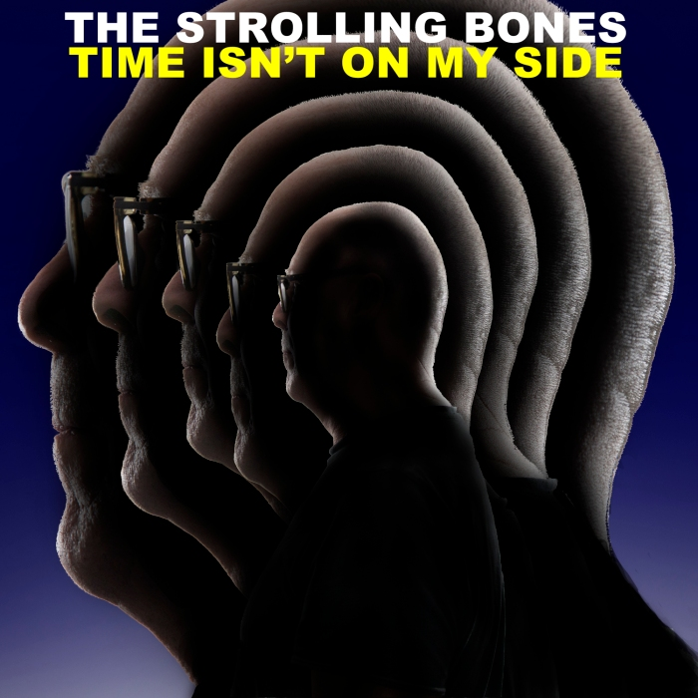Artwork [Design] – Michael Gross
Photography By [Cover] – Ron Raffaelli
Assignment 3. Self portrait. The Rolling Stones contact sheet
This contact sheet shows how I had to experiment with the lighting and my own body position to get the right effect i.e. the backlighting to create a silhouette with a halo. This whole process is very difficult, and a matter of trial and error when you are having to do everything on your own!

Wednesday 30TH December 2020
I woke up this morning already thinking! Normally I like to wake and allow myself a bit of time to prepare for the exertions of thinking.
These happenings can be very enlightening, but can also catch you at unawares! The subject of these thoughts has come to be known as The Gollum thoughts. Slowly but surely, they have now become a major force. Once they were nothing, so nothing that they took up none of my time. Nothing to fuel them, but still they grew and now they are something significant.
All the time I’m away from Beren & Eledhwen it feels like wasted time, my fear being that during this time they can/will be thinking ill of me (like I am). Thinking about the time I didn’t…… or the time I shouted…… So, on and so forth! Then, when I get home or wake them up in the morning it is all so cursory and full of empty platitudes, yet there is so much more, so much heart. Will they ever analyse it enough to see that? I don’t know. And so, I feel the mounting presence of panic, like knowing your Marathon rival is hunting you down, getting nearer with every step. I think I can hear his breath just behind me. This morning we listened to the radio in the truck. Heard Don McClean’s American Pie, and subsequently downloaded the full-length version to my phone. Now I can’t get it out of my head! When I’d dropped the children off at their respective locations, I turned the radio off. A bit of thinking time, it’s always good to have, yet somehow, I fritter it away, chatting with Dysi, making up words and rhymes.

Thursday 31st December 2020
Melancholy! That’s the word I was thinking of a couple of days ago. That feeling usually reaches its height tomorrow. After which, normality and the ‘same old same old’ crushes it. This year my staff have all had holidays, so covering means the workload hasn’t allowed me the time to be melancholic. I think that is probably a good thing as I hate that feeling. It can, if wallowed in for too long lead to dark places, ideally not visited.
Children to Nana and on to work. Radio was rubbish and I didn’t want my own music on so we had some mindless chat. I think this was just to cover up, or offer an olive branch, not sure who by though, all because I’d shouted at them both just before leaving the house (with due cause). Beren was his usual resilient self, but Eledhwen (who was the main object of my rant) was a little less forgiving. Still! She’ll get over it.
(I decided to get out my favourite fountain pen and continue my entries with it).
It’s nice to write with a fountain pen, it slows you down a bit. It still doesn’t help me write in lower case though! After forty years of writing in upper case I have decided now is a good time to try to return to the joyous flow and rhythm of lower-case script. I’m also struggling to make it look tidy too! Nevertheless, it does feel very nice to be doing it.
It was a long day at work, finishing at six. Only really because I wanted to finish the year with no loose ends.
Home alone! Sally taken children to Nana’s for tea. Nice just to relax and hear the whistle of silence. Sally came home, showered and went to bed- zero interaction! I tried to see in the New Year, but could only manage about eleven o’clock. The wine was good though as conciliations go!! UB40 Red red wine! Phhhhhh! Sure, fairly representative of the day, a non-event, significant in history, but for me, not to be remembered for anything special.

Friday 1st January 2021
“All is quiet on New Year’s Day, a world in white gets under way”. Well not exactly snow, but a heavy frost for sure. Children with Nana and a lay in. A slow start but Sally called out to see some calves with pneumonia meant I didn’t really get going until about eleven!! Not melancholy yet!...
Children come back at two o’clock. Nice to hear their voices, they play well together especially for a boy & girl aged nine & six. Once they’d come in and given us their news and recounted the day to us, they did what they often do and disappear into some technological device of some sort or other.
Currently drinking the day away (not on a bender, just quietly sipping the Whiskey Mack’s), which is not conducive to diary writing.
New Year’s resolutions? Nahh, I don’t really do them, as they generally set me up for a fall and ultimate disappointment and a bit of ‘self-beating up’! I do try to improve on certain things sometimes, but never start on New Year’s Day, as that is still part of the holiday.
When I was, I’m going to say eighteen, I was still living at home. This particular New Year’s Day was cold, with snow on the ground. Filled with melancholy, I went out for a walk, really just to get away from everybody, just to be left with my own thoughts. I ended up going up Cockayne Hatley Hill, a steady walk up a country road out of and up above the old Bedfordshire market town of Potton. Out into the deathly silence, a muffled silence deadened by the snow. It was cold, and I was cold, but the solitude was comforting, and perhaps even warming on the soul. I’ve always remembered that walk with both detail and affection, my best ever New Year’s Day!
At ten pm there was a knock at the back door. Odd! I opened the door to a young woman, strangely dressed (Bobble hat, cropped green tweed jacket, black leggings, knee length patterned blue socks), perhaps on the skinny side of slim, with mousey blonde straggly shoulder length hair and a pale/sallow complection. She asked in a rather confused way, “Does Jake live here?” She said that she’d been told he did. I tried to ask some logical questions to see if I could help, but she gave a sharp look sideways (presumably to an accomplice in the shadows), made her apologies and left! Initially it was mildly amusing, but thinking on a little later, I couldn’t help but wonder if she was a traveller casing the joint for later on! Thirty mins later and worry got the better of me, and I was togged up and doing a quick recce of the village, to no avail.
Tiredness finally overtook worry at about one a.m. and I went to bed.

Saturday 2nd January 2021
Lazy start to the day, doing the mundane; washing, putting washing away, filling the dishwasher, make breakfast for the children etc etc.
Then it all got a bit interesting! Beren had a ‘Tiktok Incident’. This needed to be dealt with correctly and tactfully. I think I managed it well? Had I not taken an early step back, and just balled him out, that would have done nobody any use at all. On this occasion, treating him as an equal, like an adult, worked very well. Ultimately, important lessons were learnt but the severity of the situation was put across.
I thought that coming to parenthood later in life would carry with it the advantage of patience. However, I've found that when tested, my patience Isn’t that good. I’ve constantly beaten myself up about it, and tried at every opportunity to improve and be more understanding. It is another one of those things that I don’t want my children to remember me for!
Sally has been out until two p.m. doing her thing, but has then come back, and I feel like I’m constantly being disturbed. Jeez I’m grumpy. I know I’m grumpy and I know why I’m grumpy. Worst of all, I’m almost enjoying being grumpy. I need to start going to bed early, I’m shit when I’m tired!
We both spoke to Beren about his internet ‘adventure’. I’m so very proud of him sometimes, he analyses and deals with things in such a mature way sometimes.
I wish I had the self-discipline to write my diary every day. When I write/record, I realise there are so many things that get forgotten over time.

Monday 4th January 2021
Today I got up feeling old! It took me a very long time to get up to speed with life. I wish things would move on and I could just get these knees replaced. Not only am I missing out on life, it is holding us back as a family.
Friends of ours sent us a picture and text resume of their 2020. It really brought it home to me what we are missing out on. There were pictures of them all climbing hills in the Lake District, going on long family walks. These are all the sort of things I used to do every single weekend! My children have never known me when I was ‘active’. Bloody COVID is robbing me! I need to get these fucking knees done and fast. Before I know it my family will have flown the nest, and all they’ll have for memories of me are those of a miserable old bugger that never went out with them. I want to be able to risk life and limb again going ‘balls out’ down steep gravelly terrain on a mountain bike, or get back into serious rock-climbing weekends teaching my own flesh and blood to love the great outdoors. Now? Now the gym is my only playground, and even that is shrinking, as slowly, one by one, it becomes impossible to use the various apparatus.
Later today, Sally and I discussed the ideas and possibilities of opening our own CrossFit cum Bouldering wall business. After the adrenaline buzz had ebbed and flowed, I was left to think on about the whole idea, and I wasn’t sure whether I was excited or not. Was I even disappointed? Very confusing!
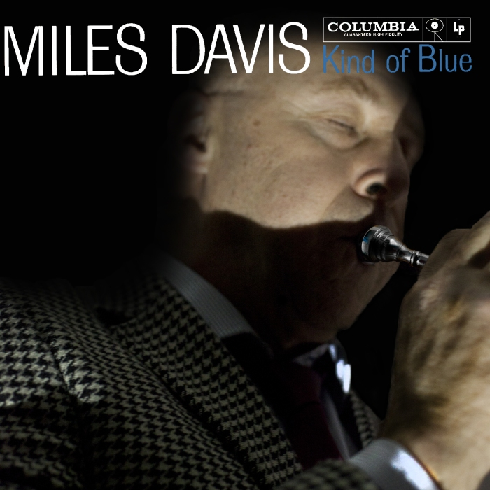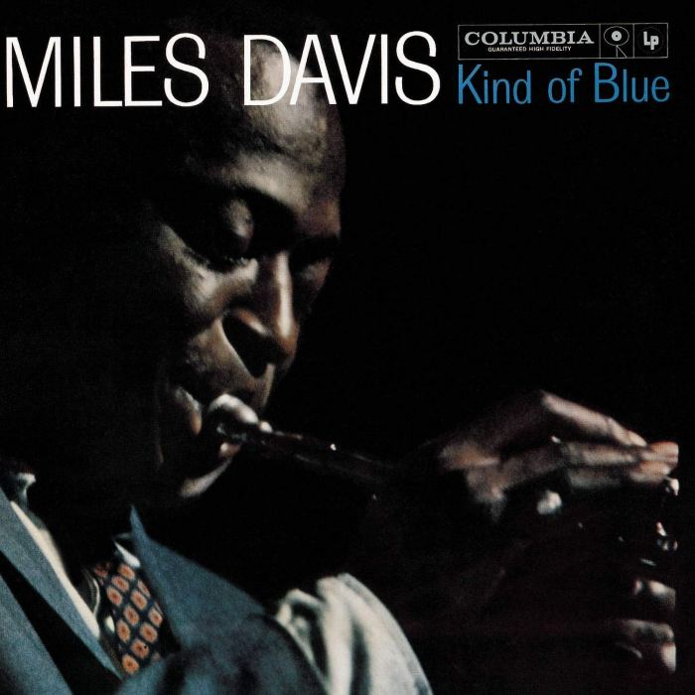Original photo © Jay Maisel
Assignment 3. Self portrait. Miles Davis, Kind of blue contact sheet
As with most of these contact sheets, there is not a great deal of 'development' to see, as this is all done, and evident in the 'TIFF' image.

Tuesday 5th January 2021
Went out to my truck this morning, only to find that my plug and lead to charge my phone were missing. FUUUUUUCK!! Sally drove it last night but denies all knowledge. Fuck am I pissed off about it. It’s my fucking truck and she doesn’t give a shit about it! She neither cares nor has any respect for what is mine. Fuck I wish I could ban her from using it. Fuck fuck fuck!!! Last week they stank it out by eating their fish & chip, and pizza in it, then leaving the boxes in it and chips in the carpet! Fuck I’m pissed off. I love that truck, I treat it with the utmost respect every day, then those fuckers just wreck it! I think it is so rude and disrespectful that they don’t have the common decency to respect other people possessions and property. The irony is that in actual fact, she (and Brendan (Other director)) own the truck, and it is ‘part of my package’ so I’m actually paying for the ‘gift’ they are giving me. If I trashed it and totally disrespected it, I bet they would be the first to point it out to me! Sally asked me this morning if there was something wrong, ‘did I have a problem?’ For once, I told her straight. I felt a lot better straight away, even if it did make her mad and deny it. I should express my feelings more often, instead of bottling it up so as not to create a confrontation. Thing is, it is actually (through years of practice) easier to deal with it internally, than it is to bear the brunt of people who you’ve pissed off by telling them that they’ve upset you. How fucked up is that?!! But I piss them (Sally) off when I deal with it by sulking anyway, so might as well deal with it head on!! Once it was out there, the rest of the day/evening went smoothly, so therein lies the lesson!
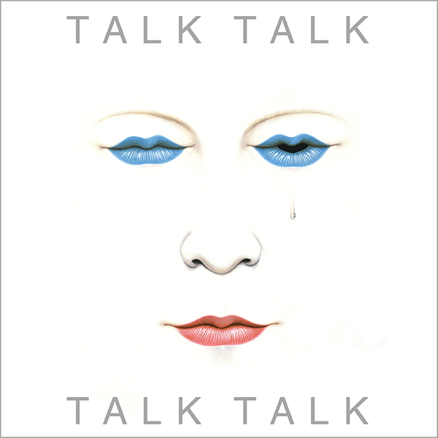Artwork & design by James Marsh https://jamesmarsh.com/design/singles
Assignment 3. Self portrait. Talking Heads contact sheet.
This contact sheet does show a little bit of experimentation with trying to produce the correct lip shape, and also the eyes, before progressing to the final idea which was an adaptation of the original, rather than a mimic of the original.

Wednesday 6th January 2021
Today has been full on manic from the moment I got to work, until the moment I transferred the phones to the ‘vet on call’.
Even though I hadn’t eaten anything since a bar of chocolate at 07.45 a.m. I was still able to knock three seconds off of my rowing time ( Dysi & I like to call the Crosstrainer the Crossdresser & the Rower, the rowing boat; It amuses us! Though not strictly dyslexia, I still share it with her. It goes without saying that ‘The bike’ becomes ‘The Bicycle’!!). I’m pretty pleased with that, though I know that shaving three seconds off of a ‘PB’ just means that I wasn’t trying very hard the time before. Ha! That said, in the space of a little under four minutes, I went from feeling pretty fucked off with the world, to feeling pretty stoked! Trouble is, I now want to celebrate with a bottle of wine and an unhealthy pudding.
Now starting to see the effects of the Christmas excess living! I’m looking a bit portly, so I need to weigh in and keep at it on the rower.
I didn’t mind looking a bit heavy pre first lockdown, but then we holidayed in the South of France, and it was so hot that I didn’t want to eat or even drink much beyond water. Consequently, in just two weeks I lost a stone. Since then, I can feel when I start to put it on. That’s kind’a good!
Now that Beren has a SIM card it is really quite nice that, when I’m thinking about him, I can text him to say hello. It’s a really nice feeling that I have a way to communicate with him when I’m not stressed. Even though they are spontaneous, I hope he is able to look back in years to come and remember them as such. It is a great way for me to ease the burden I feel daily, that ‘Daddy is an Ogre who is always cracking the whip, whilst Mummy is always the good guy, buying the treats and evening everything out.
I know my father was a (very) good man and worked hard to provide for us, and I have no negative feelings towards him whatsoever, but I have no strong recollections of him showing us lots of affection either. My children must NOT look back on their childhood with those sentiments. Yet I hear the clock ticking and the sands of time falling ever louder. Don’t leave it too late Miles, DO NOT!! I’m never going to be perfect, but that shouldn’t stop me from trying. A fine line… a constant tightrope.

Sleeve design by: Peacock & Queen with additional design by Richard Gray
http://www.ultimatequeen.co.uk/queen/songs/greatest-hits-iii.htm
Assignment 3. Self portrait. Queen, Under pressure contact sheet
Again, the contact sheet doesn't really show any of the thought process, (this was very intuitive) neither does it show the stages of the construction, as this can only really be seen in the 'TIFF'.

Thursday 7th January 2021
Whilst looking for inspiration for another single/album cover, I realised I'd wandered into a head rant! I was mentally re-enacting my next tutor meeting. So, assuming my next assignment (3) was going to be criticised for a lack of depth: “I’m not going to pander to current sycophantic trends. I will not jump on the already burgeoning bandwagons of ‘Black lives matter’ & ‘My poor COVID life’. YES, these things are important, very important, but everybody is using these issues as a vehicle to gain respect or rise above the dross of mediocrity, just to get their fifteen minutes of fame. In doing so, they are creating the new mediocratic dross by their sheer numbers. I will not do this shit! I value my own integrity and will not compromise myself. If doing this is what it takes to get my work passed by an examiner, then FUCK YOU! I will quit this course tomorrow and never mention it to a soul for fear of the shame and self-loathing that it would bring on.
Peel back another layer to reveal something new, grab the limelight, get the attention. For Fuck Sake! Is that it? Is that the only way to make a justifiable image now? What do they call it in policing? Something about ‘Cold cases. There isn’t that much we can do in Photoshop that we couldn’t do with film in a darkroom. I can’t help but think though, maybe photography/photographers jumped on the ‘progress train’ and couldn’t get off as it quickly gathered a head of steam. Maybe we should go back a few years and ‘cold case’ some eras, see if we missed something. Instead of, let’s say, studying Francesca Woodman’s photographic history and just mimicking what she did before her untimely death, maybe let’s look at where she was going maybe extend or extrapolate her work, produce something new. It doesn’t matter how many skins you peel off, an onion is still an onion!

Wednesday 13th January 2021
Received a phone call today from Taunton Hospital to ask if I would consider another hospital for my knee replacement. “Of course, I’d travel to Scotland at the drop of a hat if I had to”. Ok we’ll send you an appointment for Shepton Mallet (1 hour away). If I waited for Taunton, it may be into next year before I get an appointment (I’ve been waiting two years already). I’m very excited!

Thursday 14th January 2021
Received letter today. Appointment on Monday!! Wow, now I’m seriously excited. Do I get on the rowing boat and really bugger it up (the knee)? I don’t need to, it is knackered, we all know that, there are X-rays to show it. I’ve gone through this thought process every time there has been a (false) dawn, a possible step closer.

Monday 18th January 2021
A bit nervous and a bit apprehensive. Typically, my knee feels quite good today! Maybe I should have a hard session on the rowing boat today. Don’t be stupid Miles, you don’t need to. Yes but…. And so it goes, and so it goes (Nick Lowe).
When I think back to when the troubles first started, it was twenty years ago in Guatemala. Ever since then it has been constant discomfort. Twenty years of constant discomfort! There have been times, many times, when I haven’t even been able to get down the stairs. It’s now been over two years since I started the process of getting a permanent fix for it. And now, hopefully the time has come.
It didn’t start well! The surgeon invited me in to the consult, and I was made to stand, much like a naughty school boy in the headmaster’s office. Understandable of course, but still a bit unnerving. He looked at my X-rays and then said that he didn’t want to replace my knee as the prognosis is never good unless the condition was “bone on bone”. I was really taken aback, and reeling at the prospect of having to go to the back of the queue. Fortunately, before I’d had chance to formulate a response, he noticed that the X-rays were two years old. At which point he said that I should go down to X-ray dept. and get some new ones. Forty-five minutes later I was back in his office. It was clear from the X-rays that my condition was now ‘Bone on bone’. After taking the time to explain all of the possible consequences and percentages of all the things that could go wrong, he looked me straight in the eyes, smiled and asked” So, what would you like to do? I said, “Having listened and taken on board everything both you & Mr. Kelly have said, I would like to go ahead with a full replacement of my knee”. All this was said whilst trying to present an air of gravitas and solemnity, whilst fighting back the urge to laugh and cheer loudly. After that, there was an hour of ECG’s, blood pressure testing and blood taking, and form filling too.
I can’t begin to explain the relief. The thought of being able to do ‘stuff’ without constantly worrying about all the damage I’m doing, not to even mention the pain and discomfort, and weeks of tenderness following a single thirty-minute walk to the beach and back or kicking a ball in the garden with Beren. I almost daren’t begin to believe it is actually going to happen. I now have to wait for a phone interview on Monday. But still, it must be imminent, as he has sent me away with a bottle of Hibiscrub to use prior to surgery!!
Can this really be it? I feel as though the very act of thinking about it, is tempting fate. Will COVID scupper my plans once more?....
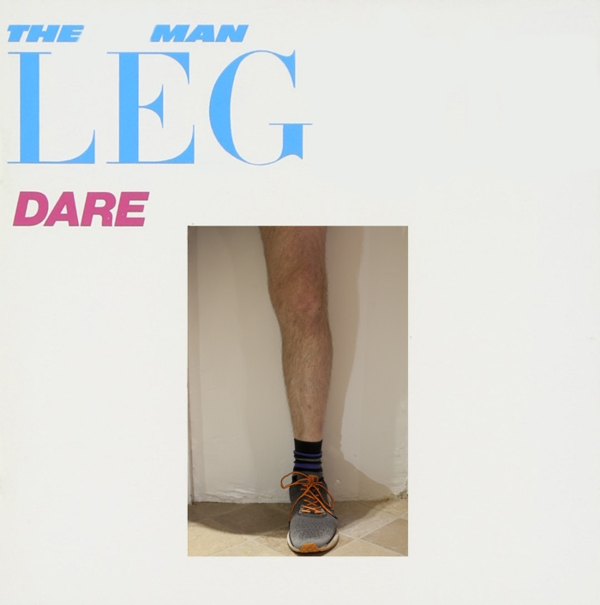

Cover design by Oakey and Wright, with photography by Brian Ars
assignment-3.-self-portrait.-the-human-league contact sheet
This contact sheet, like the 'Rolling Stones' one, shows how it is all about trial and error when you have to do all of the jobs. By the number of images, you can see that I have started to get much more of a feel for positioning and lighting.

Monday 25th January 2021
The long-awaited day is here! It’s finally here. The woman, Sarah, calls, bang on time, 10.00 a.m. “Sorry Mr. Butteriss, there are some sick members of staff, I’m going to have to call you later, is that ok? “. “Yes, of course, no problem at all” I said, hoping that my easy-going helpful aspect would be duly noted on my record, elevating me up the ‘patient waiting’ list. “12.00 ok?” she said. “Yes, that’s fine by me, no rush, whenever you have the time”. She called me back at 12.25.
And so the process of two steps forward and one back continues! The bottle of Hibiscrub turned out to be a Red Herring! "Thank you for confirming all of your details, I'll put you on the waiting list for surgery at Shepton Mallet hospital".

Tuesday 26th January 2021
I read an article by a colleague of my wife’s a couple of days ago. He is the president of the BVA (British Veterinary Association). As vet politics and governance goes, this is top of the tree!
He is a strong advocate of mental health and well-being, having had is demons to deal with and has been happy to share them with a view to helping others. What I found out from his interview though, was that he has/suffers from/is afflicted with dyslexia. This spiked my interest, so I went back to the beginning and read it again, very slowly! What I read was a revelation to me, it stopped me dead in my tracks. It has consumed my thoughts ever since (three full days!).
I have never seen a ‘professional’ about my dyslexia, I have always just dealt with it and worked with/around it. What I found out was that it is a lot more far reaching and complex and diverse than I had ever realised. Far more than just seeing words jumbled up.
He struggles with sentence structure (paragraphs too) and retention of the information therein. This was like somebody throwing a large bucket of iced water over me.
Get this! I have never been able to read a paragraph, even a very short one, then repeat back or explain the contents of it, without going back and reading it at least five times. Even then it is sketchy! I can’t truly put into words how difficult, time consuming, and frustrating it is trying to study. All the time, in the back of my mind is the constant nagging voice telling me I am getting further and further behind! The harder I concentrate, the harder it is to retain anything. Tying facts together that should create a bigger picture is near impossible. Ultimately, I have to take each single snippet of information, research it until I understand it, and have a large coat hook to hang it on, before moving on to the next part of the sentence! To grind out the understanding of a couple of sentences and tie it all together can take me an entire evening. This is intertwined with my mind going off at tangents. I don’t mean about things that are weighing on my mind, like what to get when I go shopping, or ongoing problems that may need sorting at work. No, my mind will just wander, picking up totally random words and play with them, repeating them over and over, until it comes into my consciousness and I am able to (somehow) address it and refocus.
Writing my own thoughts isn’t a problem in itself, and by and large I don’t confuse letters or suffer from the more commonly perceived issues associated with dyslexia, but I really struggle! I particularly struggle with paragraph construction, even when having read and understood (eventually) P.E.E.L.
It always takes me the full two years to complete each module, by which time I am totally exhausted, but have no time to recover, as I then have to sign up to the next module or be kicked off!! In fact, I am now questioning whether I should continue with the course. Can I really sustain this battering for another six years? I’M NOT STUPID! Fuck, it is sooo frustrating that it drives me to tears some times.
I’ve always just accepted this shortcoming and never analysed it or even questioned why others don’t experience this. My attention span is poor too. Ten minutes maximum, before I have to get up and have a wander around.
I’m not stupid, but the frustration I have carried around all my life weighs heavy, very heavy, and greater with the passage of time (how very poetic!). I think that in a way, dyslexia is the opposite of, what I see as a sister curse, autism, in so much as that I am much more relaxed with life and its associated shit!
I could have achieved so much more! That is my frustration! I still have a thirst and yearning for knowledge, but I have to accept that it is something that is never going to be fulfilled. It’s an itch that will never go away.
I have a favourite book, The Silmarillion, by J.R.R Tolkien. It comprises of about twenty stories that are all interconnected, that form something akin to the Bible. I don’t know how many times I have read it from start to end, but I’m guessing it must be twenty times. There is one particular story that I have read as a stand-alone story probably one hundred times. Even now, I could not recount the story without getting the timeline wrong, or forget certain names or events within the story. This after one hundred times!! This is by far my longest diary entry. In a way, it is proving to be a bit of a catharsis. I’m actually really enjoying scribbling away, listening to the soothing noise of the nib of my fountain pen scratching away on the paper.

Thursday 28th January 2021
On some odd occasions over the last couple of years, Sally and I have talked about a combined multifaceted business. It started as my idea of opening a climbing/bouldering wall. As we talked about it, it developed into an idea whereby we would combine a building to house a climbing wall with a Crossfit gym, a yoga/conference room and possible other bits and pieces. Well today our business landlord had a catch-up meeting with Sally. One thing leads to another and he mentioned putting up a building and putting a gym in it for a captive
audience of about 250 people (long story). Sally got all excited and said about 'her' idea of having her own Crossfit gym. She is now going to ask him back, to put the idea to him.

Friday 29th January 2021
I was invited in on the meeting. Sally put her idea to Andrew (Landlord) and he agreed it was a good idea. I hadn't said very much at all, which eventually pricked Sally, and she then wedged in the idea of a bouldering wall. This was also met with positive vibes. It was agreed we'd reconvene in a couple of weeks to discuss further.

Sunday 14th February 2021
Off she goes, down to the office for the morning for her workout. As I’ve said, I don't mind looking after the children, they're actually of an age now where they are not only entertaining themselves, but they entertain me too! Anyway, she comes back, fanny's about for a bit then says she's going in the living room to do some more research on her gym. Well that pissed me off! Sulk mode! After a few hours we finally bumped into each other again. She had some great placating lines, which to be fair, held up. The financial figures I had come up with were way too big for what we could do as a joint venture, but "let's work the wall idea into a part of the overall plan". It made sense. I said that I had realised that her business model was going to be different to mine and that I was going to have to 'go it alone' and seek another financing method. We both agreed that was correct. Just as I was
beginning to feel ok about it, the last thing she said was, "Of course you can't start your project until mine is up and running and making a profit, as you will be risking the financial ruin of our family. We will look to get the
wall up probably in a couple to three years". I was very deflated by this, but having talked everything through, I was able to put this all to one side.

Tuesday 16th February 2021
So, Sally takes control, just like the Cuckoo in the nest. When it came to it, it was a rugby style face palm off for me! Let me explain! Sure, she has the financial backing of her current business (EFV), but this was built up over
twelve years. Twelve years of my sacrificing. All those weekends where she just worked through, leaving me to do whatever (else needed to be done). I was happy to do it (By and large), it served the greater good. And it did, we are finally in a better stable place. Now, she wants to do it all again, again her plans her wishes and ideals. What about mine, what about all that sacrifice I made for you? So, after the obligatory sulk I finally decided I was on my own and would have to look to finance my own wall. I need to look into 'Crowdfunding', grants, loans and cashing in my private pension.
One of the most underrated songs (obviously in my opinion) is U2’s ‘Red Hill Mining Town’. They never performed it live from its inclusion on their seminal, Joshua Tree album until it (the album) was celebrated by their world tour of 2017 (which Sally & I went to see at the Stad de France). It is all about the miner’s strikes of 1984/85, and their lives beyond the picketing and the headlines. It is about them and their families. The opening line hurts my heart! “From father to son, the blood runs thin”. Bono explores the damage ‘beyond the lines’. We look at how it affected the families, and the strains and division that tore families apart. Generations were torn asunder, some never to be repaired! Then, the big clever life stopper line is, “We stoop so low, to reach so high”. He took a lot of stick for this! I think it is one of those statements that, once read, you apply to so many situations! It just levels all perspectives!

Thursday 18th February 2021
Everything has been fine today, until I come back into the office and have to sit there listening to Sally on the phone to some gym owner, picking his brains about this that and the other. It just brought it home to me how fucking selfish and self-absorbed she is. She doesn't give a shit about anybody else unless it affects her! She's basically just pushed me aside. So, I’m now expected to sit back, put up and shut up whilst she sets about building another business that she wants! Twelve fucking years I’ve given over to the last business venture. And now I’m going to be expected to continue in that vein whilst she does it all again! Fetching & carrying, drop this pick up that do this go and get that. So, after half an hour I’d had enough and left, picked the children up from Nana's and took them home to make their supper. When Sally finally came back, having first done a gym session, I was in a shitty mood and could not help but let it show (obviously on purpose). She got her shit together, said goodbye to the children and went to her mum's for tea as she always does on a Thursday (not a problem).
"You stoop so low to reach so high" (From Red Hill Mining Town,
Joshua Tree album). Thank you, Bono!



U2's 'The Joshua Tree'. Album cover artwork by Anton Corbijn
The thing is; am I saying this about her, or am I saying it about me?
Assignment 3. Self portrait. U2, The Joshua Tree contact sheet
From this contact sheet you can see that i have the positioning side of things nailed. The thing that required more subtlety was the tonality and graining.

Sunday 21st February 2021
The sad and pathetic process which I insist on playing out, finally comes to the end game. I sulk and make her life miserable until she finally snaps! And at that point I am finally able to unload my pent up feelings. I really don't know why it has to be so difficult, but it just has to go it's course before I can finally open up.
Sally came home, came to speak to me, and I looked at her with a totally fake and unconvincing smile (On purpose of course). She said "Fuck You, Arsehole" and went upstairs. That was all it took, for me to somewhere inside, feel the need to apologise and hopefully get her to listen to me. I went upstairs, and after a very short amount of dialogue, Sally, all credit to her, sat and listened to me unburden my thoughts, interspersed with apologises and acceptances of knowing what I was doing, and what nonsense I was thinking and putting us both through.
And so the process started. I got my shit off of my chest, then we sat there like adults, listening, responding, analysing and working through the situation. By the end I was able to have apologised for being an Arse, but also felt relieved at having been able to put my feelings across, and also explain that all the while, in truth I was able to see the logic in her thoughts.
Later that afternoon, we sat down, discussed and came up with a plan as to how my business venture could possibly work alongside hers. Not only that, but she was magnanimous enough to help me come up with a strategy.
Although I have already covered the theme of communicating a previous sleeve, this just goes to show the repetition that occurs in my life.
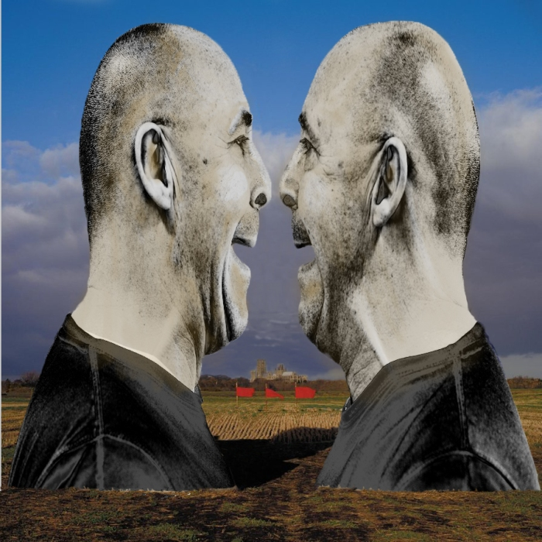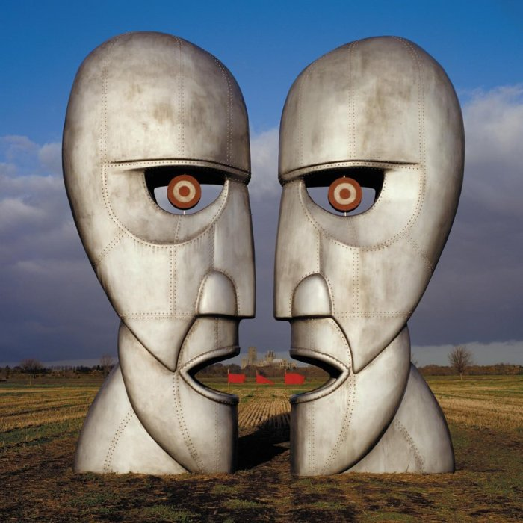Pink Floyd's 'Keep Talking' from the album 'The Division Bell'. Album artwork provided by Storm Thorgerson
Seven albums, and what I've learnt from them is that they represent reoccurring themes that happen to me on a daily/weekly basis. For me they are all albums or a song within the album that mean so much to me. If I couldn't listen to them when I wanted to, I would feel that the world was a lesser place to live in. I love music, I'm not the font of all knowledge, I am very opinionated on what's good, and what's not, but I know that is shite in itself!! Haha! Music is the heartbeat of (my) life, and without it I'd just be existing!
Assignment 3. Self portrait. Pink Floyd, Keep talking contact sheet
The contact sheet, again, gives little idea as to the thought process behind what was produced. However, as with all of the others, the final image in no way reflects the time spent creating it. The ideas were easy and intuitive, it was the laying down of them that was both hard and time consuming!
In this current climate, the natural choice would be to opt for the 'self loathing' theme. However, if you have read my learning log, you will understand why I have not gone for this option.

